Respiratory Disease Surveillance Report
Jefferson County, Missouri

Week 44: October 26, 2025- November 1, 2025

OVERVIEW: The Jefferson County Health Department (JCHD) monitors influenza and other respiratory pathogens, including COVID-19, throughout Jefferson County, Missouri. The Jefferson County Health Department conducts influenza surveillance using passive surveillance and syndromic surveillance. Although influenza illness can occur year-round, the seasonal influenza reporting begins on the Morbidity and Mortality Weekly Report (MMWR0F0F) Week 40 of a given year and continues through MMWR Week 20 of the following calendar year. COVID-19 surveillance began in March 2020 and case reporting continues year-round. COVID-19 data reflects cases that are entered into Missouri’s communicable disease database. All data and information are conditional and may change as more reports are received.

INFLUENZA SURVEILLANCE

Passive Surveillance

Table 1. Number of Laboratory-Positive1F1F Influenza Cases by Week,
Jefferson County, Missouri

CDC Reporting Week | Week Start Date | Type A | Type B | Unknown Type | Week Total
40 | 9/28/2025 | 2 | 3 | 0 | 5
41 | 10/5/2025 | 1 | 0 | 0 | 1
42 | 10/12/2025 | 0 | 0 | 0 | 0
43 | 10/19/2025 | 4 | 0 | 0 | 4
44 | 10/26/2025 | 0 | 2 | 0 | 2

Table 2. Number of Laboratory-Positive Influenza Cases by Age Group, Jefferson County, Missouri
For Cases Reported 9/28/2025- 11/1/2025

Age Group | Type A | Type B | Unknown Type | Total | % TOTAL
00 to <02 | 0 | 0 | 0 | 0 | 0.0%
02 to 04 | 0 | 0 | 0 | 0 | 0.0%
05 to 14 | 2 | 1 | 0 | 3 | 25.0%
15 to 24 | 0 | 1 | 0 | 1 | 8.3%
25 to 49 | 1 | 0 | 0 | 1 | 8.3%
50 to 64 | 3 | 2 | 0 | 5 | 41.7%
65+ | 1 | 1 | 0 | 2 | 16.7%
TOTAL | 7 | 5 | 0 | 12 | 100.0%

Figure 1. Percentage of Influenza Cases by Type,
Jefferson County, Missouri
For Cases Reported 9/28/2025- 11/1/2025

Figure 2. Number of Laboratory-Positive Influenza Cases by Week,
Influenza Seasons 2022-23 to 2025-26,
Jefferson County, Missouri

Jefferson County Influenza Outbreaks

No influenza outbreaks have been reported in Jefferson County as of Week 44.

Jefferson County Influenza Deaths3F3F

No influenza-associated deaths have been reported in Jefferson County as of Week 44.

COVID-19 SURVEILLANCE

Table 3. Number of Confirmed and Probable COVID-19 Cases by Week,
Jefferson County, Missouri

CDC Reporting Week | Week Start Date | Covid-19 Cases | Cumulative Total
40 | 9/28/2025 | 55 | 55
41 | 10/5/2025 | 45 | 100
42 | 10/12/2025 | 48 | 148
43 | 10/19/2025 | 41 | 189
44 | 10/26/2025 | 41 | 230

Figure 4. Confirmed and Probable COVID-19 Cases by Day and 7-Day Average,
Jefferson County, Missouri
For Cases Reported 9/28/2025- 11/1/2025

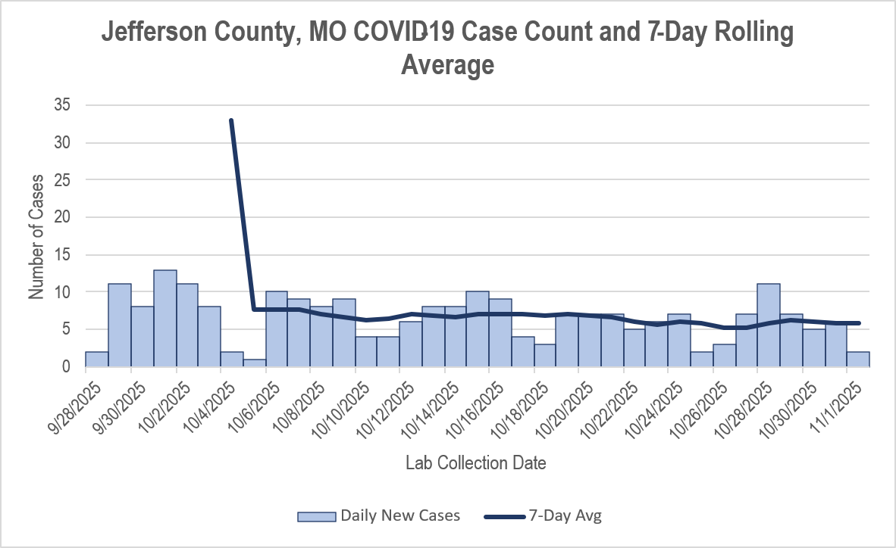

Jefferson County COVID-19 Deaths

No COVID-19 associated deaths have been reported in Jefferson County as of Week 44.

Figure 5. Simultaneous Circulation of COVID-19 and Influenza by Week,
Jefferson County, Missouri

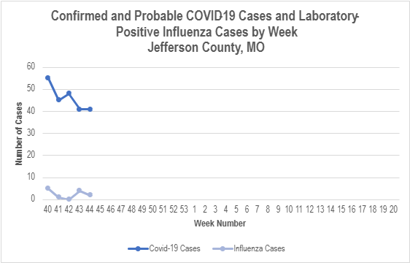

ADDITIONAL DATA SOURCES AND INFORMATION

Missouri Department of Health and Senior Services, Interactive Statewide Influenza Dashboard:
https://health.mo.gov/living/healthcondiseases/communicable/influenza/dashboard.php

Missouri Department of Health and Senior Services, Statewide Influenza Data and Statistical Reports: https://health.mo.gov/living/healthcondiseases/communicable/influenza/reports.php

Centers for Disease Control and Prevention, National Influenza Surveillance:
https://www.cdc.gov/fluview/index.html

The National Respiratory and Enteric Virus Surveillance System (NREVSS): https://www.cdc.gov/surveillance/nrevss/

World Health Organization, International Influenza Surveillance: https://www.who.int/teams/global-influenza-programme/surveillance-and-monitoring/influenza-surveillance-outputs

Passive Surveillance

Influenza is a reportable condition in the state of Missouri. JCHD conducts passive influenza surveillance by collecting and aggregating data on all laboratory-positive influenza tests in Jefferson County residents. Passive surveillance provides information on the true burden of influenza illness in Jefferson County but is limited by variations in testing and reporting practices. If diagnostic tests are not conducted on patients presenting to health care providers with influenza-like-illness, or if test results (e.g., of rapid influenza tests) are not reported to JCHD, those persons will not be included in the passive surveillance data. Thus, passive surveillance is likely an underestimate of the true burden of influenza illness in Jefferson County. Passive surveillance helps the health department to keep track of the incidence of influenza cases in the community and facilitates early detection of potential outbreaks.

Syndromic Surveillance

JCHD uses the ESSENCE system to conduct syndromic surveillance for Influenza-Like-Illness (ILI) at Missouri hospital emergency departments (EDs). ESSENCE captures data on all ED visits in persons with chief complaints (rather than final diagnoses or positive laboratory tests) of ILI. ILI chief complaints are those which include the word “influenza” or those that the ESSENCE system parses to [fever and (cough or sore throat)]. The syndromic surveillance data presented above include all ED visits for ILI from those with a Jefferson County residential address. Data from private physicians, clinics, or urgent care centers are not included in ESSENCE. Syndromic surveillance contributes to our understanding of the burden of influenza experienced by the healthcare system, as well as demonstrating the relative impact over time of influenza with respect to other illnesses.

Data is reported in epidemiologic weeks established by the CDC’s Morbidity and Mortality Weekly Report (MMWR). The MMWR week starts on a Sunday and ends on Saturday. Values for MMWR week range from 1 to 53, although most years consist of 52 weeks.
Laboratory-positive influenza includes the following test methods: rapid influenza diagnostic tests (antigen), reverse transcriptase polymerase chain reaction (RTPCR) and other molecular assays, immunofluorescence antibody staining (Direct (DFA) or Indirect (IFA)), or viral culture.
All influenza-associated deaths became reportable in Missouri in 2016.

